**Chikungunya**

***Chikungunya*** is a mosquito-borne disease caused by a virus that is spread by the bite of ***Aedes***mosquitos. Chikungunya occurs in large numbers in the Caribbean and parts of Africa.

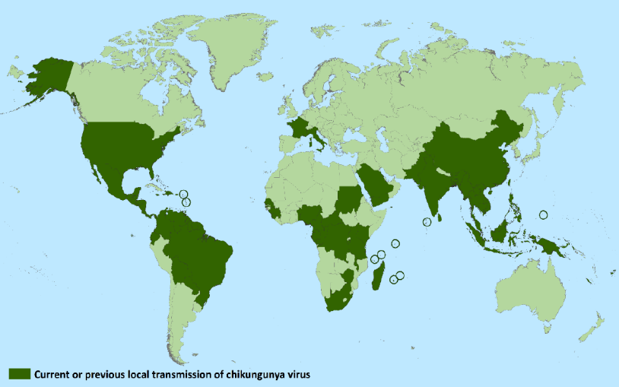

Symptoms occur **3-7** days after a bite from an **infected** **mosquito** and can last up to **several weeks to months**. Symptoms can include:

* Fever
* Severe joint pain and joint swelling
* Muscle pain
* Rash (often hive-like)
* Headache
* 

**Countries and territories where chikungunya cases have been reported (as of March 10, 2015)**

**\*\*FL is the only US state with documented local transmission of chikungunya**

***Aedes***

***Facts***

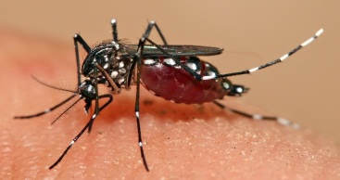

***Facts***

***Facts***

* Aedes mosquitos are **daytime biters** and often bite around the **lower legs** and **feet**.
* Aedes mosquitos breed in people’s yards in **anything that can** **collect water**, including buckets, water cans, pots, toys, wheel barrows, tires bird baths, pet bowls, boats, cans, coolers, etc.
* These *Aedes* mosquitoes **are very common in Maricopa County**, and we are at risk for having outbreaks of this disease in the Valley if we don’t take steps to prevent it.
* If you or a member of your family becomes ill with chikungunya-like symptoms after traveling in affected countries, **it is extremely important that you avoid mosquito bites for** **at least 7 days after your illness begins**. Your family members should do the same to avoid becoming infected (see prevention below).

**Prevent mosquito bites and mosquito breeding!**

|  |  |
| --- | --- |
| * Stay indoors if at all possible * Wear long sleeves and long pants | * Use insect repellents on exposed skin and on clothing |
| * Dump out any water in containers and remove or cover them | * Reapply insect repellents as directed on the label |



If you, a family member, a visiting friend or neighbor comes down with **chikungunya symptoms**, please contact public health officials immediately by calling

**(602) 506-6767**

**Dengue Virus**

***Dengue*** is a disease caused by a virus spread by the bite of *Aedes* mosquitoes and is common in parts of Asia, the Pacific, the Caribbean and Central and South America.

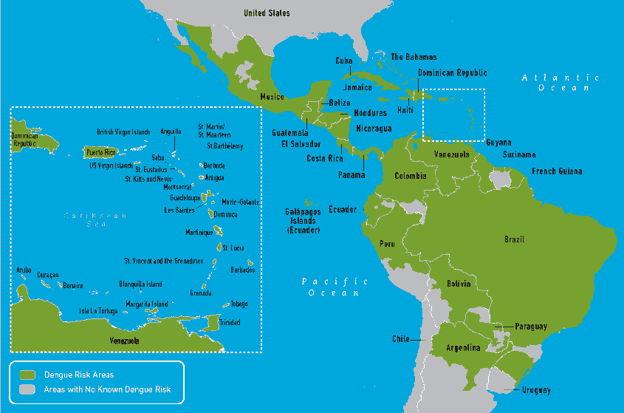

Symptoms occur **4-7** days after a bite from an **infected** **mosquito** and can last up to **10 days**. Symptoms can include:

|  |  |
| --- | --- |
| * High fever * Joint, muscle or bone pain * Rash * Nausea * Vomiting | * Severe headache and pain behind eyes * Body aches * Nose or gum bleed, easy bruising |

***Aedes***

***Facts***

* 



**Distribution of dengue risk areas in the Americas and the Caribbean**

**Countries with reported local transmission of Chikungunya virus (as of July 2014)**

***Facts***

***Facts***

* Aedes mosquitos are **daytime biters** and often bite around the **lower legs** and **feet**.
* Aedes mosquitos breed in people’s yards in anything that can **collect water**, including buckets, water cans, pots, toys, wheel barrows, tires bird baths, pet bowls, boats, cans, coolers, etc.
* These *Aedes* mosquitoes **are very common in Maricopa County**, and we are at risk for having outbreaks of this disease in the Valley if we don’t take steps to prevent it.
* If you or a member of your family becomes ill with dengue-like symptoms after traveling in affected countries, **it is extremely important that you avoid mosquito bites for at least 7 days after your illness begins**. Your family members should do the same to avoid becoming infected (see prevention below).

**Prevent mosquito bites and mosquito breeding!**

|  |  |
| --- | --- |
| * Stay indoors if at all possible * Wear long sleeves and long pants | * Use insect repellents on exposed skin and on clothing |
| * Dump out any water in containers and remove or cover them | * Reapply insect repellents as directed on the label |

If you, a family member, a visiting friend or neighbor comes down with **dengue symptoms**, please contact public health officials immediately by calling



**(602) 506-6767**